AI WeatherWise - Deliver intelligent weather forecasts and insights.

Description
The AI WeatherWise is a robust RESTful backend platform built with Node.js and Express.js, utilizing MongoDB and Mongoose ODM for data persistence. It delivers real-time weather metrics integrated with Google Gemini AI to provide intelligent summaries and personalized recommendations based on live environmental conditions.
The platform features secure JWT authentication, bcrypt password hashing, and a comprehensive suite of endpoints for managing favorite locations and fetching weather insights. It includes a resilient fallback mode ensuring API functionality even without external API keys, alongside centralized error handling and request sanitization.

Scenario-Based Case Study

Background
Alex is a travel enthusiast who frequently visits different cities and needs a streamlined way to track local weather conditions and receive AI-driven activity suggestions based on current forecasts.

Problem
- Difficulty tracking and managing multiple favorite weather locations efficiently.
- Lack of personalized recommendations for outdoor activities or clothing.
- Need for natural language weather summaries rather than just raw data metrics.
- Absence of a secure system to store and sync preferences across devices.

Solution
The AI WeatherWise provides a centralized service that handles weather data retrieval and AI orchestrations. It manages a secure User and Location database, allowing for customized insights and automated recommendation workflows through Google Gemini.

Usage
- User Usage: Manages favorite cities (CRUD), fetches real-time weather, and requests AI insights for recommendations and summaries.
- Developer/Admin Usage: Monitors API health, manages global user registrations, and verifies weather/AI service integrations.
- Weather Application User: Interfaces with the public weather endpoints to consume current metrics without requiring an account.

Outcome
By leveraging AI and centralized data management, users spend less time deciphering raw metrics. The system ensures data integrity via Mongoose schemas and provides high-value, context-aware weather advice through Gemini integrations.

1. Software Requirements
- Operating System: Windows 10/11, macOS, or Linux (supports cross-platform operations).
- Node.js (v16 or above): Runtime ecosystem running server logic and routing infrastructure.
- npm (v8 or above): Node package manager to control operational dependencies.
- Gemini AI SDK: Integration using @google/generative-ai for natural language insights.
- MongoDB: Document NoSQL engine storing users, posts, categories, comments, and analytics metrics.
- Postman: API verification toolkit to assert schema validation responses across administrative route shields.
- Code Editor: Visual Studio Code or similar IDE environment.

2. Hardware Requirements
- Processor: Intel Core i5 (8th Gen or above) / AMD Ryzen 5 or equivalent.
- RAM: 8 GB minimum (16 GB recommended for concurrent instances of MongoDB, processing layers, and execution nodes).
- Storage: 1 GB of available disk workspace.
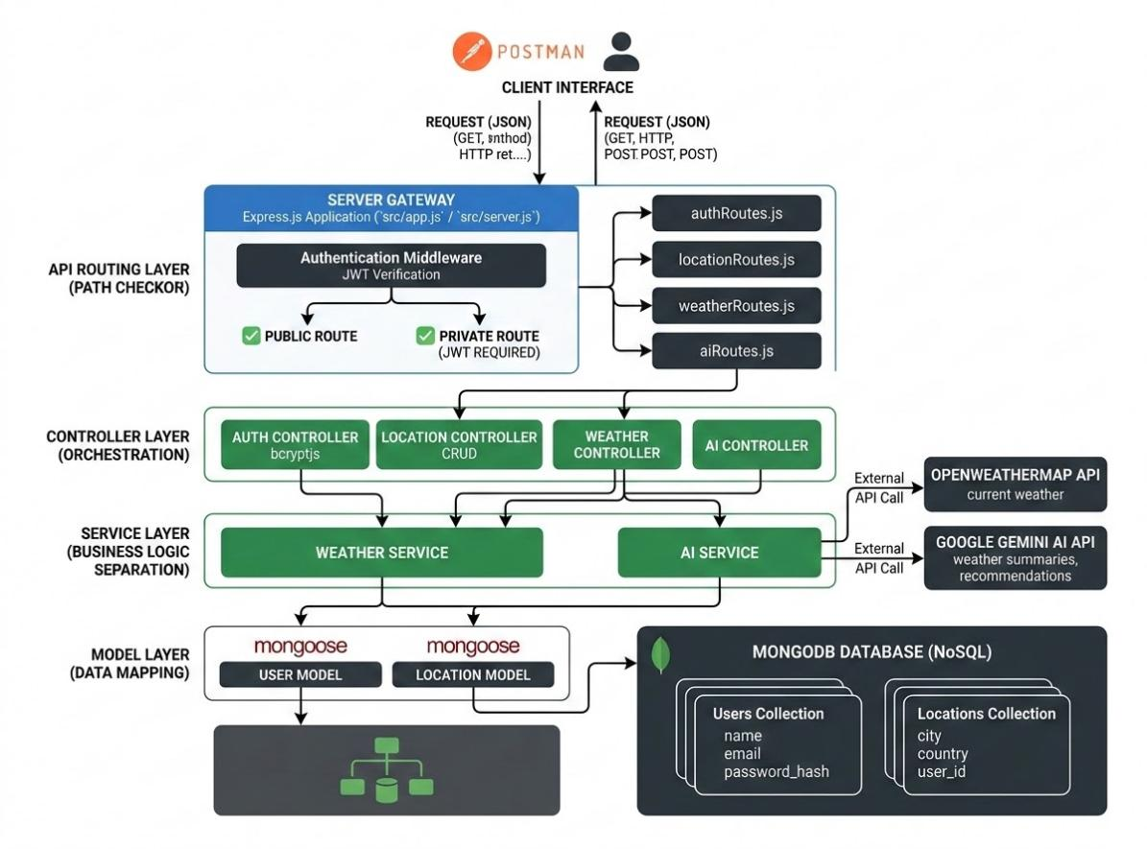
Epic 1: PROJECT ARCHITECTURE
The AI WeatherWise application follows the MVC pattern to decouple business logic from data management. The Controller layer orchestrates weather fetching from OpenWeatherMap and generation of AI insights via Gemini, while the Model layer manages User and Location entities.

Components Definition
- Interface: API tools like Postman query distinct route paths to extract JSON entities.
- Express Server Gateway: Monitors network ports, maps explicit HTTP methods (GET, POST, PUT, DELETE), parses JSON payloads, and handles CORS headers.
- Authentication & Role Matrix Middleware: Extracts tokens from headers, validates user context signatures, and evaluates if the specific role satisfies authorization thresholds for guarded resource paths.
- Granular Services (Logic Modules): Enforces isolated domain rules for blog lifecycles (Draft, Pending Approval, Scheduled, Published), comment queues, and system reporting indicators.
- Database Interface Layer: Mongoose translates operational application logic into performant native MongoDB queries.
- AI Service Integration: Leverages @google/generative-ai to generate weather summaries and personalized recommendations based on live temperature and conditions.

Entity-Relationship (ER) Diagram Description
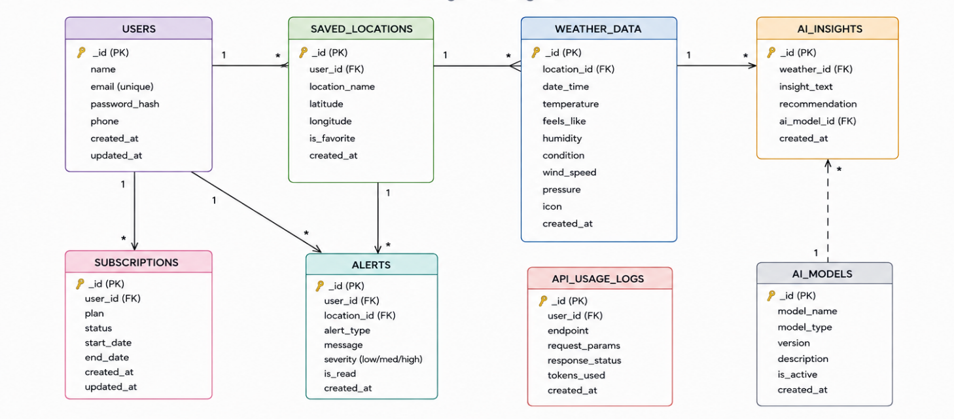The data architecture manages User profiles and their associated favorite Locations through logical references:

1. User Entity
- _id (Primary Key - ObjectId)
- name (String, Required)
- email (String, Required, Unique)
- password (String, Hashed, Required)
- role (String, Default: "reader")

2. Location Entity
- _id (Primary Key - ObjectId)
- user (Foreign Key referencing User Collection)
- city (String, Required)
- country (String, Required)
- createdAt (Date, Default: Now)

Key Structural Mappings
- User to Location (One-to-Many): A registered user can save multiple favorite locations.

Key Features
- Role-Based Route Guarding: Strict token processing blocks unauthorized tiers from modifying core settings.
- CRUD Blog Execution Engine: Complete schema management over content definitions, status states, and asset assignment paths.
- Categorization System: Native tag indices facilitate filtering and querying for enhanced discoverability.
- Comment Moderation Logic: Protected entry points for updating moderation flags (approved, pending, spam).
- Sanitization Safeguards: Payload parameter sanitation prevents XSS vectors and NoSQL parameter manipulation injections.

Roles and Responsibilities
- Admin:
  - Responsible for user account management, including creating, deleting, or suspending accounts.
  - Oversight of API health and system logs to monitor performance.
  - Monitoring and managing database integrity.
- Registered User:
  - Responsible for creating and maintaining a list of favorite locations.
  - Initiating requests for real-time weather data.
  - Interacting with the Gemini AI service for personalized weather summaries and activity recommendations.
  - Managing their own authentication credentials, such as updating profile details.

User Flow:
1. User logs in or registers.
2. User saves a favorite city via the API.
3. User fetches current weather metrics for that city.
4. User requests AI-driven insights (summaries/recommendations) based on the weather data.
5. System validates JWT and returns the requested information.
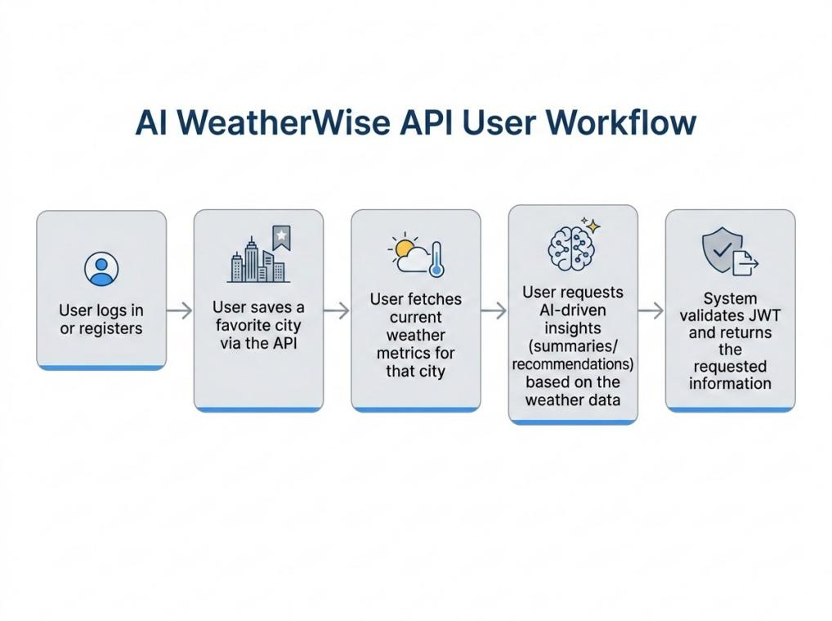
MVC Architecture Pattern
The system architecture structures its source configuration layers around the Model-View-Controller design pattern to completely decouple components:
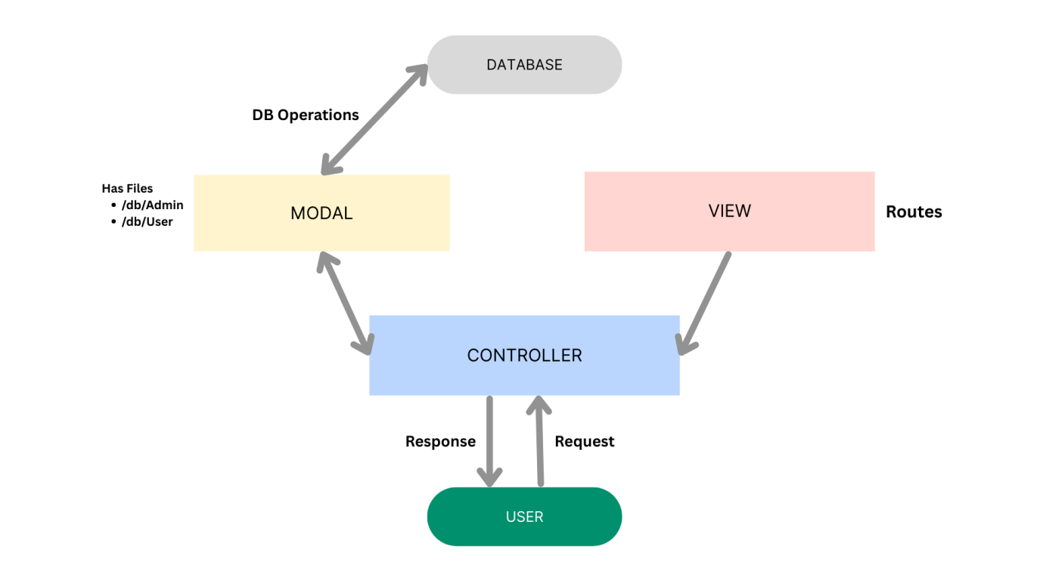

Model Layer (Data Blueprint)
Defines structure blueprints via strongly enforced Mongoose schemas mapping explicit fields into raw collection items inside MongoDB. It sets default states, indexing rules, and transformation parameters before validation persistence occurs.

Controller Layer (Execution Matrix)
The intermediary brain of the ecosystem. It captures request vectors from the execution routes, checks structural request constraints, delegates processing workflows directly to models, and packages the resultant output into standard JSON return arrays.

View Layer (Routing Network Interface)
In this pure headless backend service context, standard user-interface template views do not exist. Instead, the interface layer lives as an API Routing Layer. It links network requests on specified paths directly to their associated controller handler logic maps.

Epic 2: Project Setup and Configuration

Creating the Project Folder
- Create a new folder named AI Weatherwise
- Open the project folder in Visual Studio Code.
- Initialize the project using Node.js and install the required dependencies.

Project Initialization
Open the project folder in the VS Code terminal and execute:
npm init -y
Install the required dependencies:
npm install express mongoose bcryptjs jsonwebtoken cors dotenv multer @google/genai
Install Nodemon for development:
npm install --save-dev nodemon

Create the Following Files
- index.js
- .env
- package.json
- .gitignore

Create the Following Folder Structure
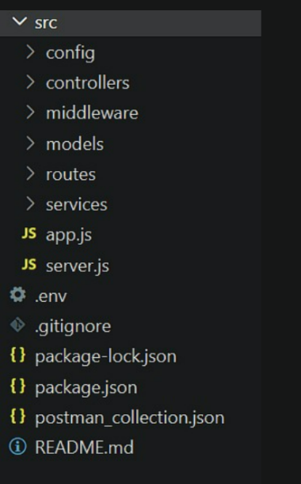

Environment Configuration
Create a .env file in the project root and configure the required environment variables.
PORT=5000
MONGO_URI=your_mongodb_connection_string
JWT_SECRET=your_jwt_secret
GEMINI_API_KEY=your_gemini_api_key

Epic 3: Backend Development
The AI weatherwise backend is developed using Node.js, Express.js, and MongoDB, following a modular architecture. The application separates routing, controllers, middleware, models, and utility modules to improve code maintainability and scalability. The backend exposes secure REST APIs for authentication, study material management, AI-powered content generation, and administrative operations.
Backend Structure:
Core System Script Implementations
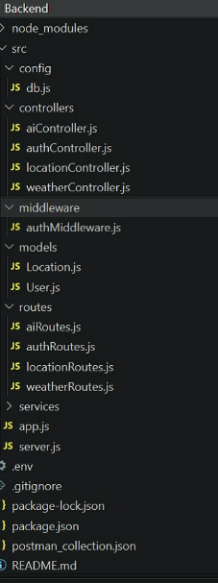

1. Application Entry Point (index.js)
The index.js file serves as the main entry point of the application. It initializes the Express server, loads environment variables, configures middleware, establishes the MongoDB connection, registers API routes, and starts the server after a successful database connection.
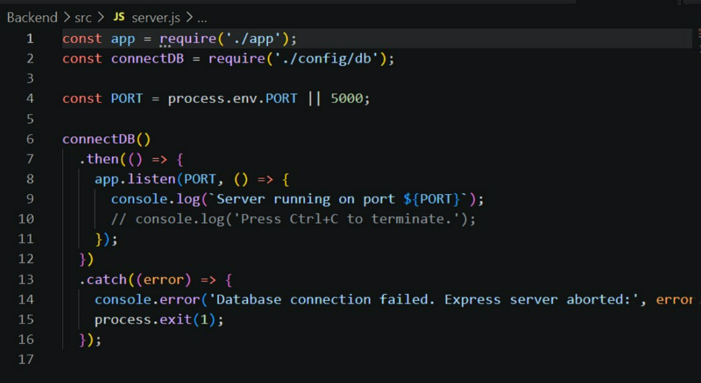

Epic4: Database Configuration
API Testing Demo :

1. Configure MongoDB:

- Install Mongoose.
In your Node.js project directory, run:
npm install mongoose
- Create database connection.
- Create Schemas & Models.

Create Database connection:
Now, make sure the database is connected before performing any of the actions through the backend. The connection code looks similar to the one provided below

Mongoose Schema Definitions
Location Schema:
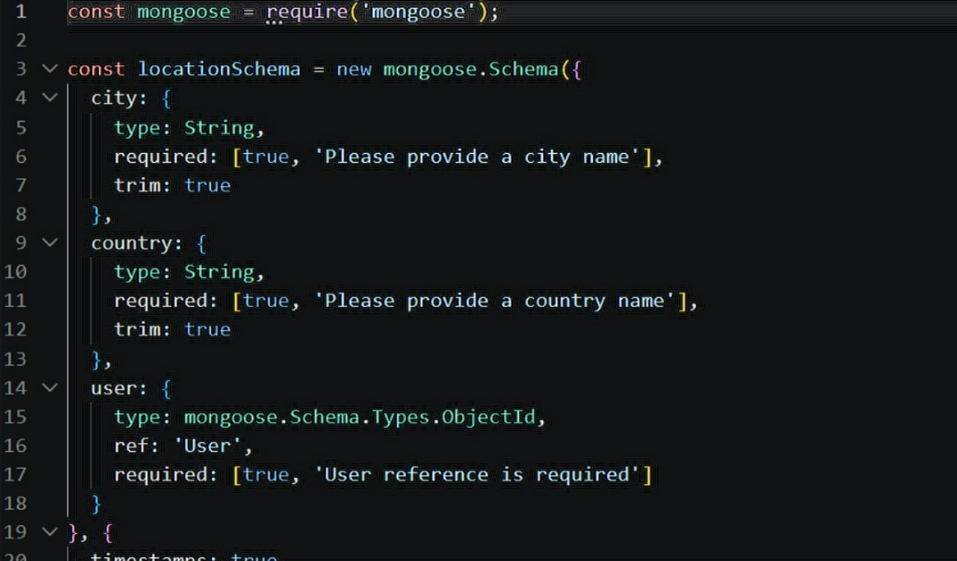

User schema:

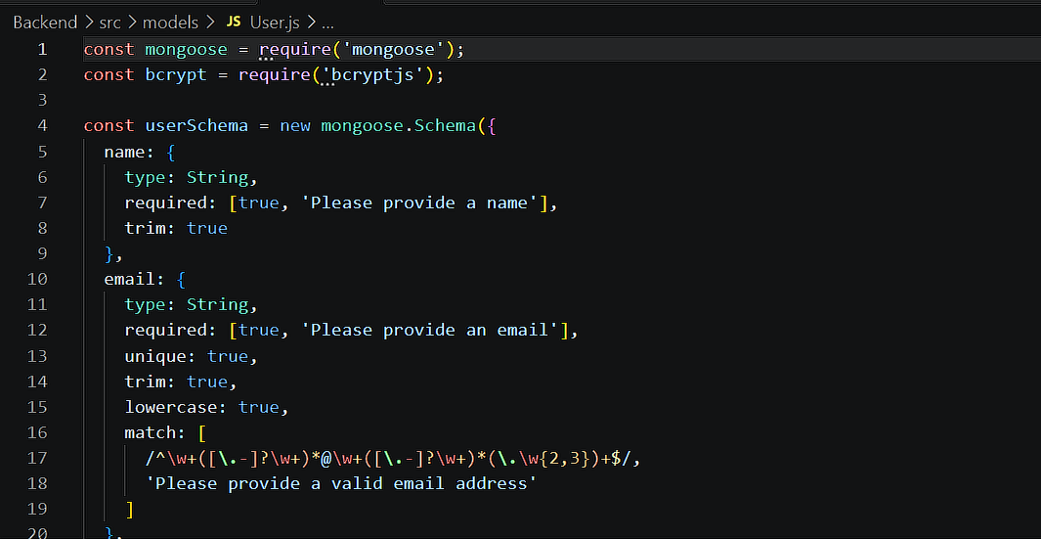

Db connection:
This module establishes a connection between the application and MongoDB using Mongoose. It ensures that the backend communicates with the database before processing any client requests.

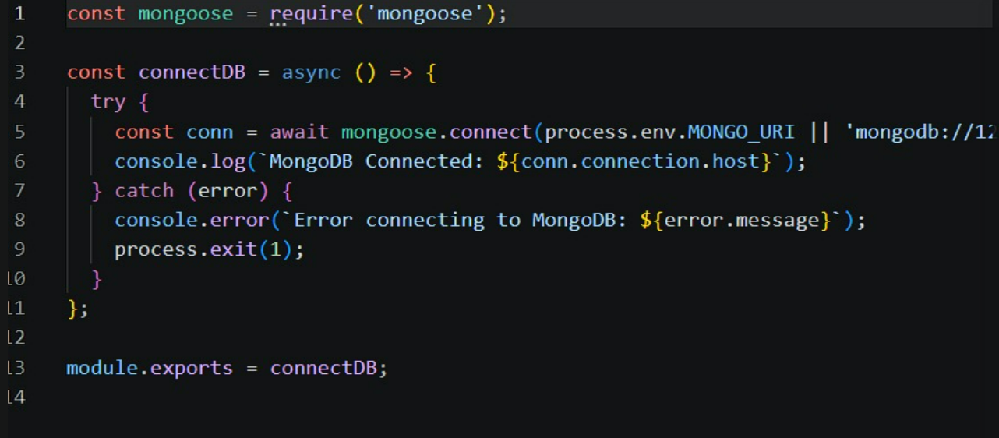

Epic 5: Project Executions:
The AI weatherwise backend can be executed locally using Node.js. Before running the application, ensure that MongoDB is running and the required environment variables are configured correctly. The backend exposes REST APIs that can be tested using Postman or Thunder Client.

Running the Backend Server
Install all required dependencies:
npm install
Start the development server:
npm start
After successful execution, the server connects to MongoDB and starts listening for incoming API requests.
API TESTING:
REGISTER API:
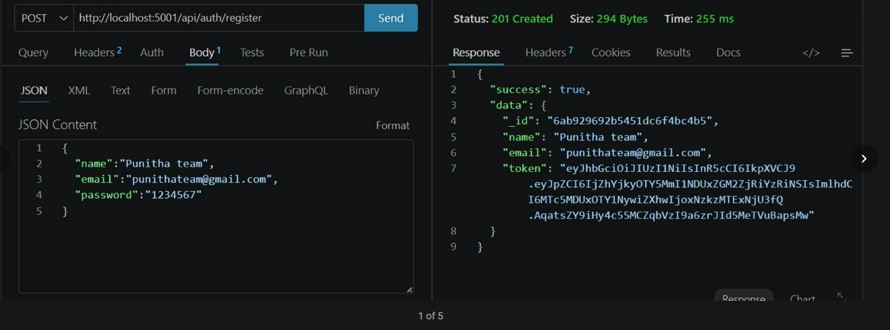

LOGIN API:
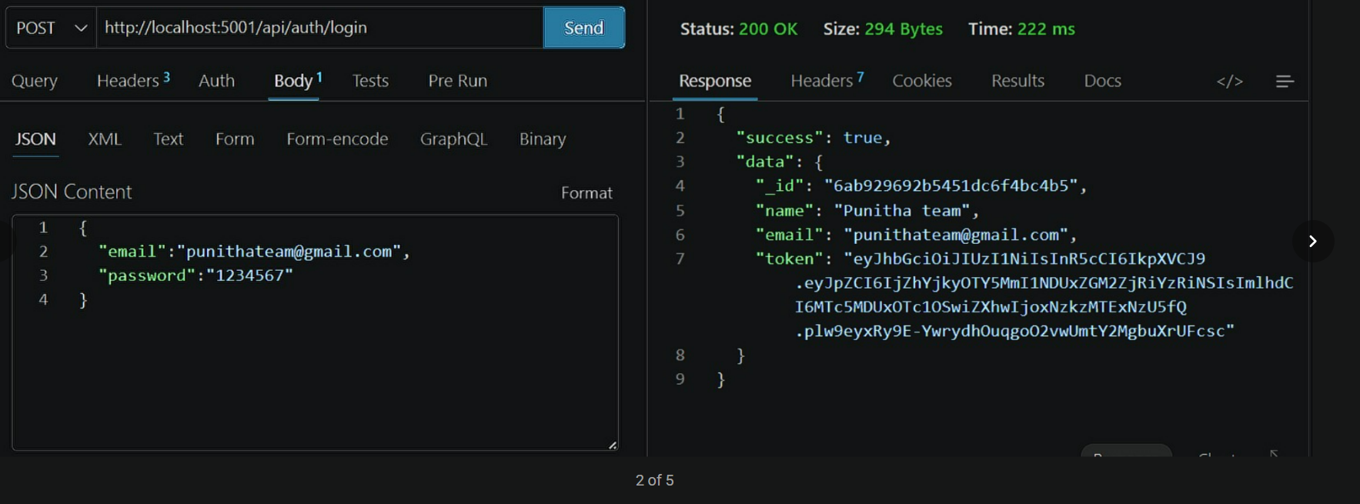

WEATHER API:
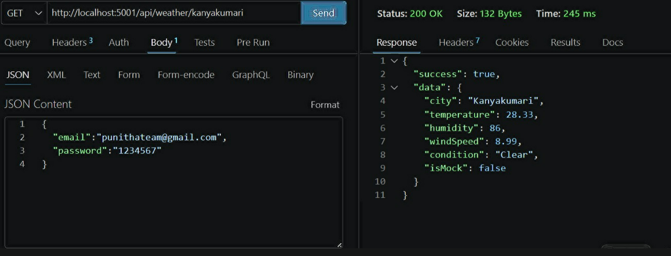

RECOMMENDATION API:
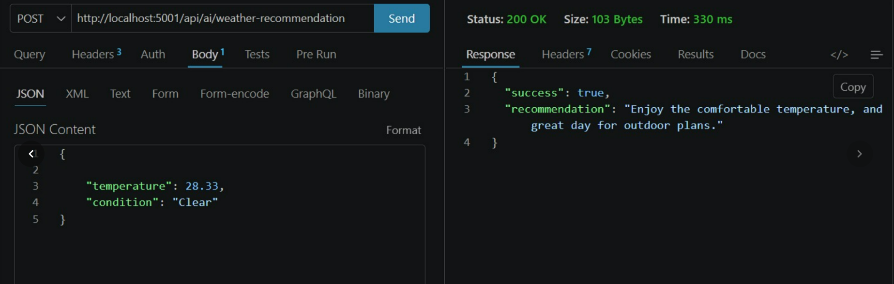

API testing video link:API testing.mp4
Demo Video Link: Backend demo.mp4
CodeDrive:Code

